Taskify Backend Postman Request and Response
1. Create Task
Method: POST
URL: http://localhost:5000/tasks
Request Body (JSON):
{
"title": "Buy groceries",
"description": "Milk, Bread, Eggs",
"dueDate": "2025-05-01",
"priority": "Medium",
"status": "Pending"
}
Response Body :
{
"title": "Buy groceries",
"description": "Milk, Bread, Eggs",
"dueDate": "2025-05-01T00:00:00.000Z",
"priority": "Medium",
"status": "Pending",
"_id": "6810baeb3ce29f53265c9994",
"__v": 0
}
2. Get All Tasks
Method: GET
URL: http://localhost:5000/tasks
(Optional query params: ?status=Pending&priority=High)
[
{
"_id": "680f76b55b6ce10d8ae340c4",
"title": "Clean the house",
"description": "Vacuum and mop the floors",
"dueDate": "2024-05-12T00:00:00.000Z",
"priority": "Medium",
"status": "Pending",
"__v": 0
},
{
"_id": "680f77665b6ce10d8ae340c7",
"title": "Switch on the fan",
"description": "Job is to switch on the fan",
"dueDate": "2025-05-30T00:00:00.000Z",
"priority": "High",
"status": "Pending",
"__v": 0
},
{
"_id": "680faca228bf492bcd9d7e79",
"title": "Complete Project Proposal",
"description": "Write the first draft of the project proposal for the client meeting.",
"dueDate": "2025-05-05T00:00:00.000Z",
"priority": "High",
"status": "Pending",
"__v": 0
},
{
"_id": "680facf428bf492bcd9d7e7b",
"title": "Validate Project Proposal",
"description": "Validate project proposal for the client meeting.",
"dueDate": "2025-05-10T00:00:00.000Z",
"priority": "Low",
"status": "Pending",
"__v": 0
},
{
"_id": "680fad2e28bf492bcd9d7e7d",
"title": "Complete Review Project Proposal",
"description": "Complete Review of project proposal for the client meeting.",
"dueDate": "2025-05-12T00:00:00.000Z",
"priority": "High",
"status": "Pending",
"__v": 0
},
{
"_id": "6810a2b83ce29f53265c997d",
"title": "Prepare Tea",
"description": "Tea leaves, Milk, Water, Sugar",
"dueDate": "2025-05-01T00:00:00.000Z",
"priority": "Low",
"status": "Pending",
"__v": 0
},
{
"_id": "6810b55e3ce29f53265c998c",
"title": "Purchase sweets and snacks",
"description": "Rasagolla, Samosa, Kachori, Gulabjamun, Kaju Barfi",
"dueDate": "2025-05-05T00:00:00.000Z",
"priority": "Medium",
"status": "Pending",
"__v": 0
},
{
"_id": "6810baeb3ce29f53265c9994",
"title": "Buy groceries",
"description": "Milk, Bread, Eggs",
"dueDate": "2025-05-01T00:00:00.000Z",
"priority": "Medium",
"status": "Pending",
"__v": 0
}
]
Method: GET
URL: http://localhost:5000/tasks?status=Pending&priority=Low
[
{
"_id": "680facf428bf492bcd9d7e7b",
"title": "Validate Project Proposal",
"description": "Validate project proposal for the client meeting.",
"dueDate": "2025-05-10T00:00:00.000Z",
"priority": "Low",
"status": "Pending",
"__v": 0
},
{
"_id": "6810a2b83ce29f53265c997d",
"title": "Prepare Tea",
"description": "Tea leaves, Milk, Water, Sugar",
"dueDate": "2025-05-01T00:00:00.000Z",
"priority": "Low",
"status": "Pending",
"__v": 0
}
]
3. Get Task by ID
Method: GET
URL: http://localhost:5000/tasks/{task_id}
http://localhost:5000/tasks/680faca228bf492bcd9d7e79
{
"_id": "680faca228bf492bcd9d7e79",
"title": "Complete Project Proposal",
"description": "Write the first draft of the project proposal for the client meeting.",
"dueDate": "2025-05-05T00:00:00.000Z",
"priority": "High",
"status": "Pending",
"__v": 0
}

4. Update Task
Method: PUT
URL: http://localhost:5000/tasks/{task_id}
Body (JSON):
Before
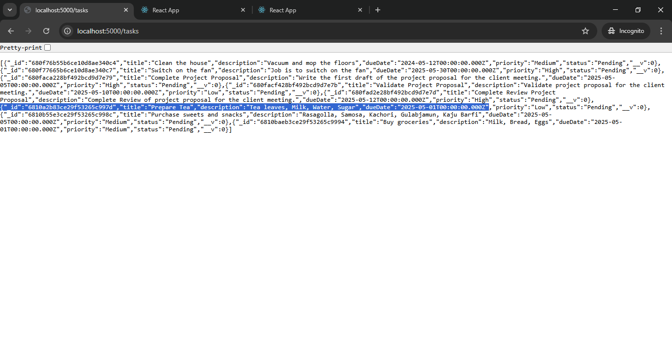
http://localhost:5000/tasks/6810a2b83ce29f53265c997d
Request Body
{
"title": "Prepare Tea and Coffee",
"description":"Tea leaves or Coffee powder, Milk, Water, Sugar",
"status": "Completed"
}
JSON Response
{
"_id": "6810a2b83ce29f53265c997d",
"title": "Prepare Tea and Coffee",
"description": "Tea leaves or Coffee powder, Milk, Water, Sugar",
"dueDate": "2025-05-01T00:00:00.000Z",
"priority": "Low",
"status": "Completed",
"__v": 0
}
5. Delete Task
Method: DELETE
URL: http://localhost:5000/tasks/{task_id}
Before
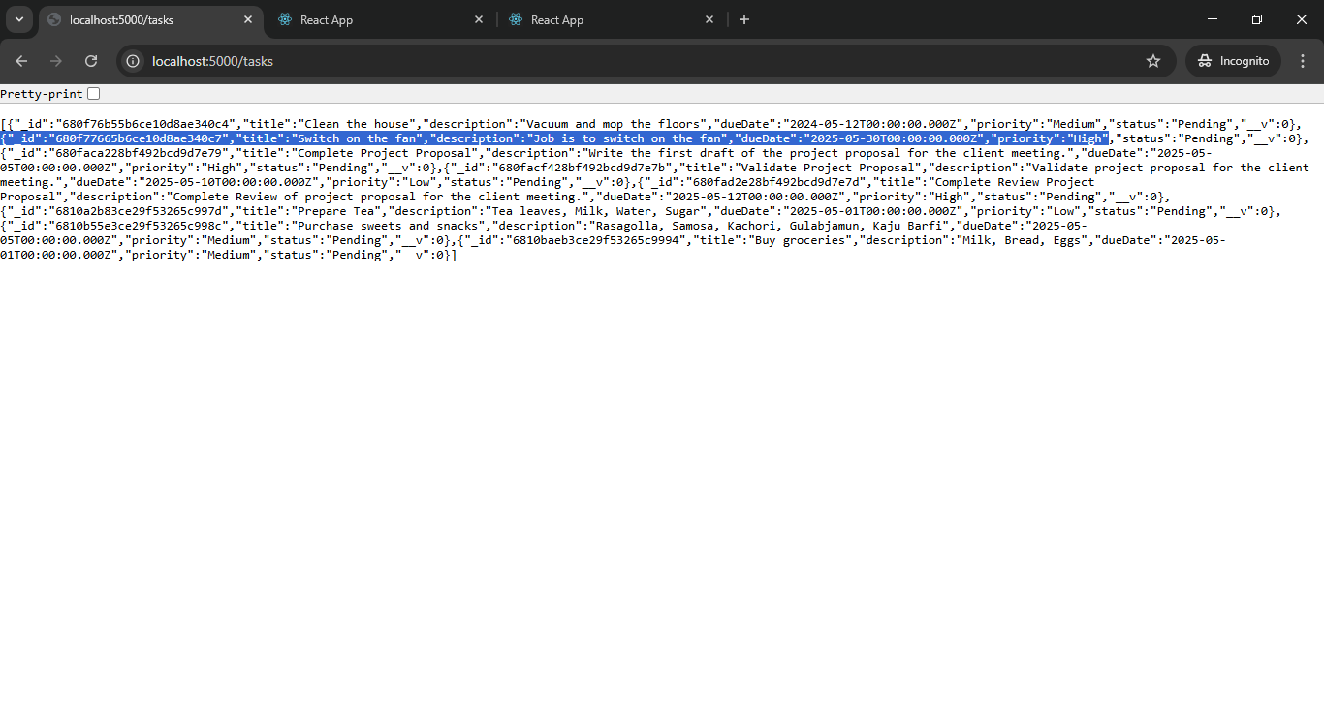

DELETE http://localhost:5000/tasks/680f77665b6ce10d8ae340c7
{
"message": "Task deleted"
}
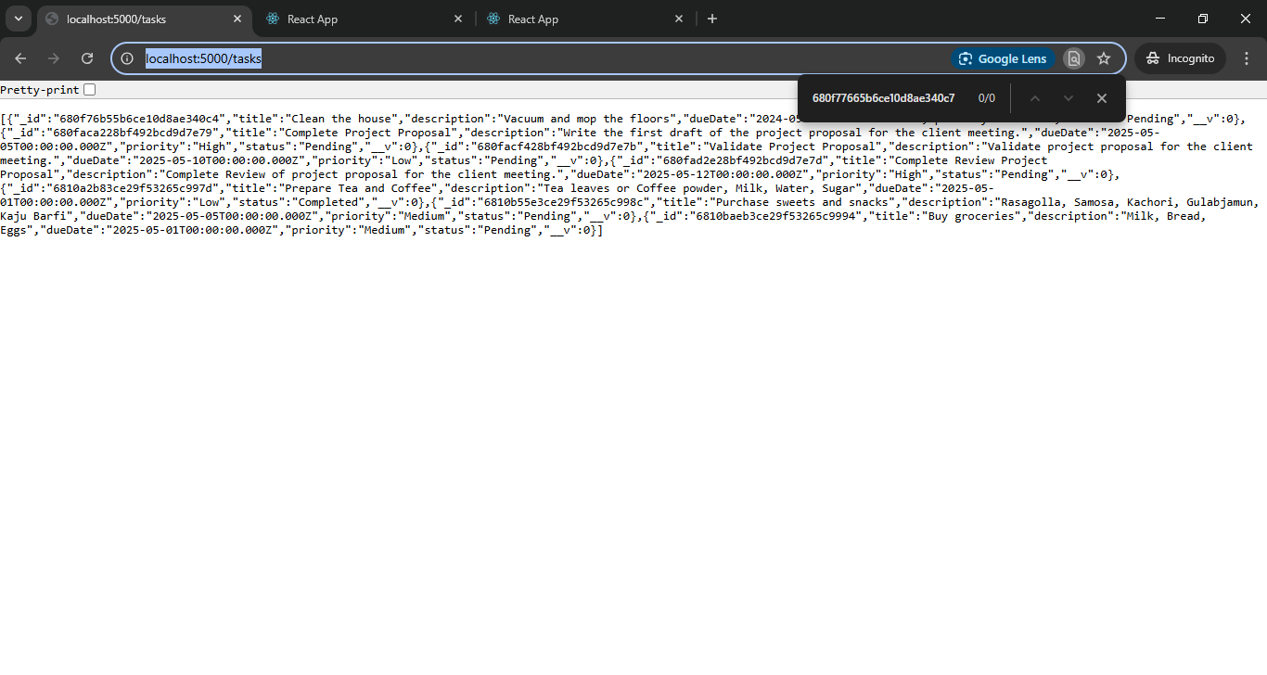
Document is prepared by Jayashree Das

